**8051 MicroController Architecture:**

**What is 8051 MicroController?**

* An [8051 microcontroller](https://www.geeksforgeeks.org/introduction-to-8051-microcontroller/)is an 8-bit Harvard architecture microcontroller and it consists of a CPU, RAM, ROM, I/O ports, timers, and serial communication ports all combined on one chip.
* It can control simple to highly complex operations in embedded systems since it can carry out instructions which are retrieved from its internal memory.

**Diagram:**

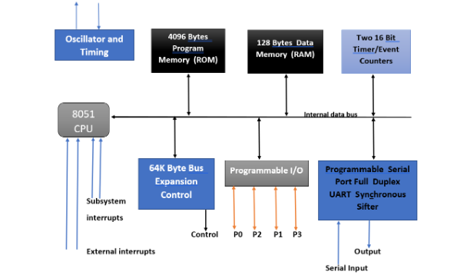

**key components of 8051 microcontroller:**

1. **Oscillator and Timing**: The oscillator generates a clock signal, and the timing circuit ensures synchronized execution of instructions.
2. **4096 Byte Program Memory (ROM)**: Non-volatile memory for storing program code, typically 4KB in size.
3. **128 Byte RAM**: Volatile memory for temporary data storage during operation.
4. **Two 16-bit Timers**: Timers: Timer 0 and Timer 1 are the two 16-bit timers on the 8051. These clocks may be used for counting events, monitoring time intervals, and creating time delays, among other things.
5. **64 Byte Bus Expansion Control**: Enables interaction with external memory and peripherals.
6. **Programmable I/O Ports**: Four configurable ports (P0–P3) for diverse input/output operations.
7. **Programmable Serial Port (UART)**: Serial communication is made possible via the Universal Asynchronous Receiver/Transmitter ([UART](https://www.geeksforgeeks.org/universal-asynchronous-receiver-transmitter-uart-protocol/)). It can send and receive data concurrently while operating in full duplex mode.
8. **Synchronous Shifter** Data is shifted in and out of the microcontroller in synchrony using a synchronous shifter. It is frequently employed in communication protocols when exact time is necessary.
9. **8051 CPU**: Executes program instructions, manages data flow, and performs arithmetic and logic operations.

**Working Principle of the 8051 Microcontroller**

The **8051 microcontroller** works by fetching instructions from its memory, decoding them, and then executing them sequentially. It performs tasks according to the program written in memory, and interacts with external devices using **I/O ports** and **timers**.

**Construction of 8051 Microcontroller:**

The **8051 microcontroller** is built using **CMOS technology** and integrates all essential components into a single silicon chip, ensuring reliability and compactness.

1. **Central Processing Unit (CPU)**: The CPU is responsible for executing all instructions within the microcontroller. It processes commands and manages the execution flow of the program.
2. **Interrupts**: Interrupts allow the microcontroller to pause its current task to address high-priority tasks. Types of interrupts are 1. Timer 0 overflow interrupt (TF0), 2. Timer 1 overflow interrupt (TF1), 3. External hardware interrupt (INT0), 4. External hardware interrupt (INT1), 5. Serial communication interrupt (RI/TI).
3. **Bus**: A **bus** is a collection of wires used to transfer data between components.

* **Address Bus**: A 16-bit bus used to transfer addresses from the CPU to memory.
* **Data Bus**: An 8-bit bus used to transfer data between peripherals and the CPU.

1. **Random Access Memory (RAM)**: RAM is used to store temporary data and variables that the microcontroller needs during operation.
2. **Read-Only Memory (ROM)**: ROM stores the program instructions that are executed by the CPU. These instructions are typically preloaded and are not modified during operation.
3. **I/O Ports**: I/O ports allow the microcontroller to interface with external devices, such as sensors, motors, or displays, for input and output operations.
4. **Timer/Counter**: The timer generates time delays, while the counter keeps track of external events, enabling tasks such as measuring time or counting pulses.
5. **Serial Communication Ports**: These ports enable the microcontroller to communicate with other devices or systems in a serial manner, such as sending or receiving data.

**Key Features:**

* **Harvard Architecture**: This means the microcontroller keeps its data and instructions in separate areas, making it faster.
* **Interrupts**: These are like alarms that tell the microcontroller to pause what it’s doing and handle something important.
* **Bit-Addressable RAM**: The microcontroller can access and change individual bits of data in memory.

**Applications of 8051 Microcontroller:**

1. **Automation Systems**: Used to control machinery and robots in industries.
2. **Consumer Electronics**: Powers everyday items like microwave ovens, washing machines, etc..
3. **Embedded Systems**: Found in cars, medical devices, and other gadgets to manage specific tasks.

**Advantages:**

* **Versatile**: Works in many different applications.
* **Compact**: All components are in one chip.
* **Low Power**: Uses very little power, so it's great for battery-operated devices.
* **Easy to Program**: Simple to understand and use for developers.

**Disadvantages:**

* **Limited Power**: Not good for heavy or complex tasks.
* **Outdated**: Some older versions don’t support modern technologies like USB.
* **Programming Challenges**: Optimization and debugging can be harder with older tools.

**PIN Diagram of 8051 Microcontroller:**

**Introduction:**

The 8051 microcontroller is a widely used 8-bit microcontroller designed for embedded applications. Its 40-pin dual inline package (DIP) provides input/output capabilities, communication options, and control features. The 8051 follows a Harvard architecture and integrates CPU, RAM, ROM, and peripherals into a single chip.

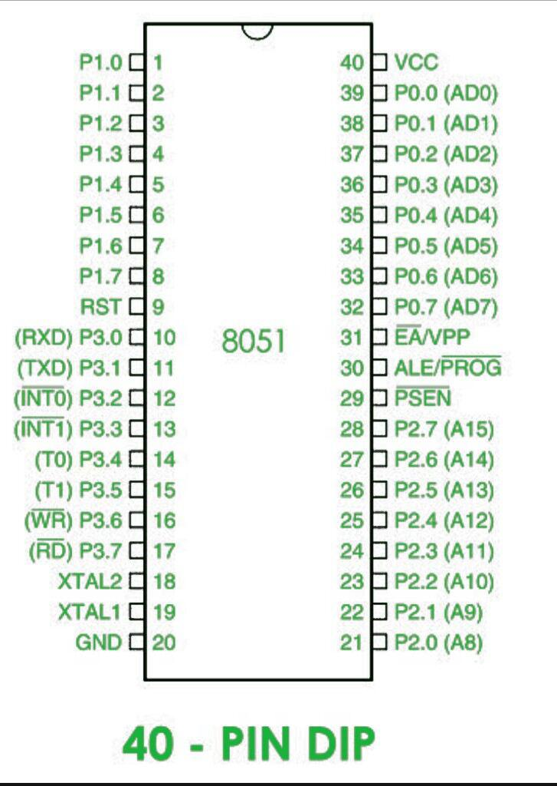

**Pin Diagram of 8051 Microcontroller:** The **8051 microcontroller** has **40 pins**.

**Main Pins and Their Uses**

1. **Power Supply Pins**:
   * **Pin 40 (VCC)**: Provides power to the microcontroller (usually +5V).
   * **Pin 20 (GND)**: Ground connection.
2. **Clock Pins**:
   * **Pins 18 (XTAL2) and 19 (XTAL1)**:
     + Used to connect an external crystal to provide the clock (speed) for the microcontroller.
3. **Input/Output (I/O) Ports**:
   * **Port 0 (Pins 32-39)**:
     + Can be used for input/output or to connect external memory. Requires pull-up resistors.
   * **Port 1 (Pins 1-8)**:
     + A general-purpose input/output port.
   * **Port 2 (Pins 21-28)**:
     + Used for input/output or to send higher-order memory addresses.
   * **Port 3 (Pins 10-17)**:
     + Used for input/output or special functions like serial communication, timers, and interrupts.
4. **Control Pins**:
   * **Pin 9 (RST)**:
     + Resets the microcontroller when triggered (active high).
   * **Pin 29 (PSEN)**:
     + Allows reading data from external memory.
   * **Pin 30 (ALE)**:
     + Helps latch (lock) addresses for external memory.
   * **Pin 31 (EA)**:
     + Decides whether to use internal or external memory:
       - **GND**: Use external memory.
       - **VCC**: Use internal memory.

(or)

**Description of 8051 Microcontroller Pins:**

1. **Pins 1-8 (Port 1)**:
   * These pins (P1.0 to P1.7) are used for simple I/O operations.
   * Configurable as input or output based on logic (0 for output, 1 for input).
   * Bidirectional pins with no alternate functions.
2. **Pin 9 (RST)**:
   * Reset pin, active-high.
   * If held high for 2 machine cycles, it resets the microcontroller to its initial state.
3. **Pins 10-17 (Port 3)**:
   * Bidirectional I/O pins (P3.0 to P3.7) with additional functions:
     + **P3.0 (RXD)**: Serial data input.
     + **P3.1 (TXD)**: Serial data output.
     + **P3.2 & P3.3**: External interrupts (INT0, INT1).
     + **P3.4 & P3.5**: Timer inputs (T0, T1).
     + **P3.6 (WR’)**: External memory write.
     + **P3.7 (RD’)**: External memory read.
4. **Pins 18-19 (XTAL1, XTAL2)**:
   * Connect to an external quartz crystal oscillator for clock frequency (4MHz–30MHz).
5. **Pin 20 (GND)**:
   * Ground connection (0V).
6. **Pins 21-28 (Port 2)**:
   * Bidirectional I/O pins (P2.0 to P2.7).
   * Act as higher-order address lines when interfacing external memory.
7. **Pin 29 (PSEN)**:
   * Program Store Enable, active-low.
   * Used to read external program memory (e.g., ROM).
8. **Pin 30 (ALE/PROG)**:
   * Address Latch Enable.
   * Helps de-multiplex address and data lines.
   * Acts as a program pulse input during EPROM programming.
9. **Pin 31 (EA/VPP)**:
   * External Access pin.
   * Connected to **VCC** to use on-chip ROM; connected to **GND** for external ROM.
10. **Pins 32-39 (Port 0)**:
    * Bidirectional I/O pins (P0.0 to P0.7).
    * Used for multiplexed address/data lines (AD0-AD7).
    * Requires external pull-up resistors.
11. **Pin 40 (VCC)**:
    * Power supply input (+5V).

This layout provides input/output operations, external memory interfacing, and communication functions essential for embedded systems.

**Uses of the 8051 Microcontroller Pin Diagram**

1. **Interfacing with External Devices**: Provides details about I/O pins for connecting external devices like sensors, actuators, displays, and communication modules.
2. **Programming the Microcontroller**: Facilitates efficient use of Assembly, C, or BASIC languages.
3. **Debugging and Testing**: Allows access to internal signals (e.g., address and data buses) for diagnostics.
4. **Expansion and Customization**: Provides flexibility for extending system capabilities.

**Issues with the Pin Diagram of the 8051 Microcontroller**

1. **Power Supply Voltage**: Requires a stable 5V supply
2. **Input/Output Current**: Each pin has a maximum current limit. Exceeding this can damage the microcontroller or connected components.
3. **Interference**: Susceptible to electromagnetic (EMI) and radio frequency interference (RFI), especially if pins lack proper shielding.
4. **Pin Conflicts**: Multiple peripherals using the same pins can create conflicts. Proper planning and circuit design are critical to avoid these issues.